A Project Report on  
  
 “Quiz Application with Multiple Choice Question”  
 Under the guidance of



Prof.Aishwarya Sakhsena in Pie Infocom Pvt.Ltd  
 Student of Jalpaiguri Government Engineering College

Md Samim Akhtar

CONTENT

Topic Page no

1)Introduction 3

2)Objective of Quiz Application 4

3)Background 5

4)Hardware and Software 6

5)Coding Introduction of the Project 7-8

6)Output ScreenShot 9-10

7)Future Scope 11-12

8)Conclusion 12-13

9)Reference and Bibliography 14-15

**Introduction:**

The Quiz Application with Multiple Choice Questions (MCQ) is an interactive and engaging project designed to test the knowledge and understanding of participants on various subjects or topics. This application provides a user-friendly platform to conduct quizzes efficiently and effectively. It can be used in educational settings, corporate training, competitive exams, or simply for fun and entertainment.

The main features of the Quiz Application include:

1)User Registration and Login: Participants can register and create an account to access the Registered users can log in using their credentials to partic

2)Multiple Choice Questions (MCQ): Each quiz question is presented in the form of multiple-choice options (A, B, C, D), where users must select the correct answer.

3)Real-time Quiz Taking: Participants can take the quizzes in real-time and receive immediate feedback on their answers, knowing whether they answered correctly or not.

And Score Calculation,Leaderboard,Timer,Review and Analysis,Share Results features are available in the quiz application .

**Objective of Quiz Application:**

The objective of the Quiz Application with MCQ project is to create an interactive and engaging platform that allows users to participate in quizzes comprising multiple-choice questions. The primary aim of this application is to:

1..Educational Engagement: Foster an environment of learning and knowledge retention by presenting users with a diverse range of multiple-choice questions on various topics and subjects. The application encourages users to test their knowledge and gain new insights through the quiz format.

2..Interactive Learning Experience: Provide an interactive learning experience that enhances user participation and knowledge assimilation. By offering multiple-choice questions, users can actively engage with the content and assess their comprehension.

3..Performance Tracking: Implement a scoring mechanism to keep track of users' scores throughout the quiz. This feature motivates users to attempt multiple quizzes and improve their performance over time.

Accessibility and Availability: Ensure the quiz application is accessible across multiple platforms, such as web and mobile devices, enabling users to participate in quizzes anytime and anywhere.

**\*Background:**

The primary aim of this project is to present users with a series of questions, each having multiple answer choices, where they can select the most appropriate answer.

1..Educational Purpose: Quiz applications with MCQs are commonly developed for educational purposes, be it in schools, colleges, or online learning platforms. They serve as an effective tool for assessing students' knowledge and understanding of specific subjects or topics.

2..Training and Assessment: Many organizations use quiz applications for employee training and assessment. These applications can be used to gauge employees' understanding of company policies, product knowledge, or compliance regulations.

3..Engaging Content: MCQ quizzes are known for their interactive nature, which helps keep users engaged. The instant feedback on their responses motivates them to improve their knowledge and try again.

4..Online Learning Platforms: With the growth of e-learning, quiz applications have become an integral part of online courses and learning management systems. They offer a way to reinforce learning objectives and evaluate learners' progress etc

**\* Hardware and Software:**

Sure! Here's a short overview of the hardware and software components involved in a quiz application project with Multiple Choice Questions (MCQ):

**Hardware Component:**

Server: A computer or a cloud-based server is required to host the quiz application and store the quiz data, questions, and user responses.

Client Devices: Users participate in the quiz using their devices such as desktop computers, laptops, smartphones, or tablets.

Software Component:

Quiz Logic: The software must implement the quiz logic, including selecting random questions, presenting them to the user, handling user responses, and calculating scores.

User Interface (UI) Design: UI design tools like Adobe XD or Sketch can be used to create an intuitive and user-friendly interface for the quiz application.

Security: Security measures should be implemented to protect user data and prevent cheating during the quiz.

The overall project would involve designing the user interface, testing the application for functionality and security. Additionally, the project may also require setting up user authentication, generating reports, and managing the quiz content dynamically.

**Coding Introduction of the Project:**

Data Organization: The code uses tuples to store the quiz questions, options, and correct answers. Each question is represented as a string, and each option is a part of a 2D tuple.

answers = ("C", "D", "A", "A", "B") # tuple of correct answer

User Input: The code prompts the user to input their answer (A, B, C, or D) for each question. The input() function is used to collect the user's responses.

guess = input("Enter (A, B, C, D): ").upper()

User Interaction: The code provides immediate feedback to the user after each question. It informs whether their answer was correct or incorrect and displays the correct answer when the user's answer is incorrect.

if guess == answers[question_num]:

score += 1

print("CORRECT!")

else:

print("INCORRECT!")

Scoring: The code keeps track of the user's score by comparing their answers with the correct answers. The score is incremented for each correct response.

**\*Output ScreenShot:**

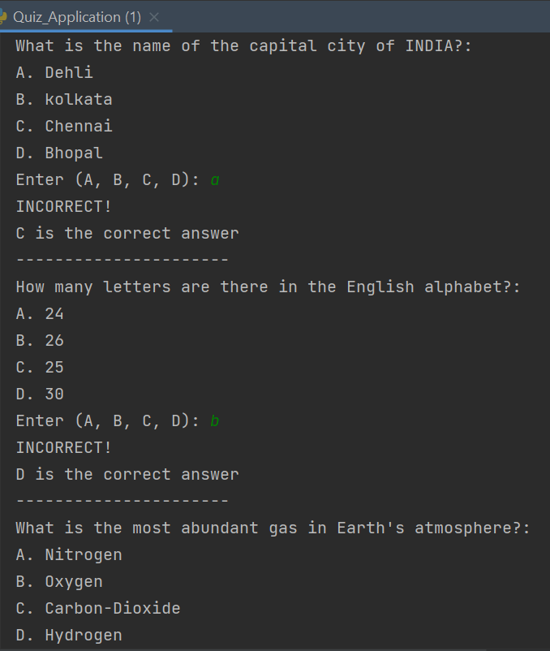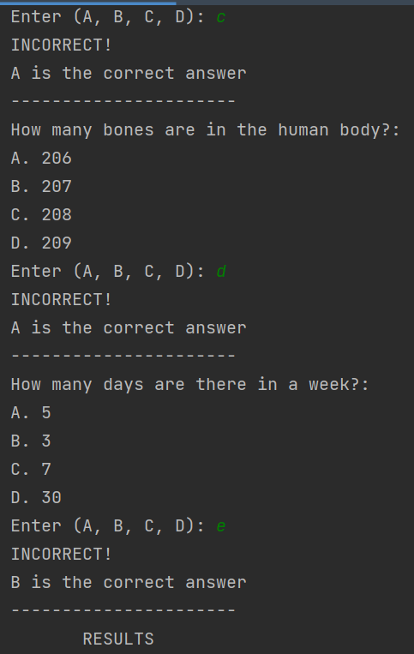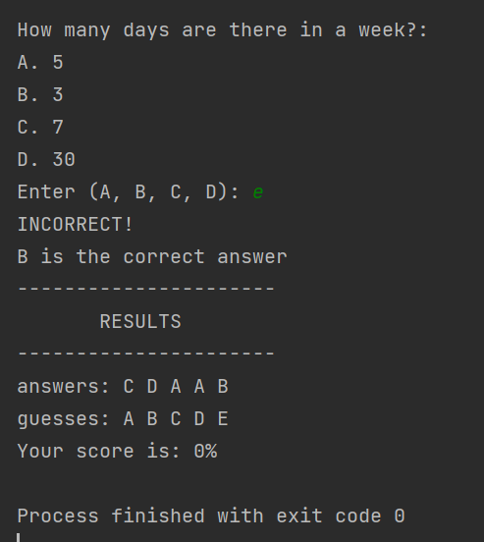

The output of the quiz application with multiple-choice questions (MCQ) project would typically involve the following components:

1..Interactive Quiz Interface:

*The application will display each question along with the multiple-choice options (A, B, C, D) for the user to select their answer.

*The user will be prompted to input their choice by entering the corresponding letter (A, B, C, or D).

*The application may validate user input to ensure it is a valid choice.

2..Real-time Feedback:

*After the user submits an answer, the application will provide immediate feedback, indicating whether the answer is correct or incorrect.

*If the answer is incorrect, the correct answer will be displayed to the user for reference.

3..Score Tracking:

*The application will keep track of the user's score as they progress through the quiz.

*Each correct answer will increment the user's score.

4..Saving User Data (Optional):

*For a more advanced application, user data such as quiz scores, completion time, and performance statistics may be stored and used for future reference or analysis.

5..Results Display:

*After the quiz is completed, the application will display the user's score, usually represented as a percentage.

*It will also show a summary of the user's responses alongside the correct answers, allowing the user to review their performance.

*Future Scope:

The future scope for a quiz application with Multiple Choice Questions (MCQ) project is promising, as it offers numerous opportunities for improvement and expansion. Here are some potential future directions for enhancing the quiz application:

a..User Authentication: Implementing user authentication and user profiles would allow personalized quiz experiences, track individual progress, and store historical performance.

b..Database Integration: Currently, the quiz questions and options are hard-coded into the application. In the future, the application could integrate with a database to store a vast collection of questions and allow dynamic retrieval of questions, enabling an ever-expanding question bank.

c..Difficulty Levels: Introduce difficulty levels for questions, allowing users to choose quizzes based on their proficiency. This adds complexity and provides a challenge for users with different skill levels.

d..Timer and Scores: Add a time limit for each question to add an element of urgency and excitement. Additionally, consider implementing a scoring system based on accuracy and time taken to answer, promoting healthy competition among users.

e..Mobile Application: Develop a mobile version of the quiz application to reach a wider audience and allow users to take quizzes on the go.

f..Subject and Category-Based Quizzes: Extend the application to offer quizzes in various subjects and categories, catering to different interests and educational purposes.

**Conclusion:**

The quiz application with multiple-choice questions (MCQ) is a simple yet effective project that allows users to participate in quizzes and test their knowledge on various topics. The project offers several benefits and conclusions:

a)Interactive Learning: The quiz application encourages interactive learning. Users actively engage with the questions, ponder over the options, and select the most appropriate answer. It promotes active thinking and knowledge retention.

b)User Engagement: Quizzes are inherently engaging, and the MCQ format adds an element of challenge and excitement. Users are motivated to participate and compete to achieve higher scores.

c)Easy Implementation: The project's implementation is relatively straightforward, making it an excellent choice for beginners in programming or educational projects. The use of simple data structures like tuples keeps the code concise and understandable.

d)Quick Assessment: The application allows for rapid assessment of a user's knowledge on multiple topics. It can be used for self-assessment or as an educational tool in classrooms and training sessions.

e)Adaptability: The quiz application is adaptable and scalable. Additional questions and topics can be easily added to expand the quiz database and enhance the user experience.

In conclusion, the quiz application with MCQs is a valuable educational and interactive tool. It encourages active learning, engages users, and provides immediate feedback. Its simplicity in implementation and versatility in application make it a widely used and appreciated project in the realm of educational technology.

**\*References and Bibliography:**

A quiz application with multiple-choice questions (MCQ) is a popular project in the field of software development and programming. Many resources, tutorials, and references are available online to help developers create such projects. Here is a short note on some key references that can be helpful when building a quiz application with MCQ:

a..Online Tutorials and Blogs: Numerous blogs and websites offer step-by-step tutorials on building quiz applications. These tutorials often cover various programming languages and frameworks, guiding developers through the process of creating the application from scratch. Examples of such platforms include Medium, Dev.to, and freeCodeCamp.

b..GitHub Repositories: GitHub is an excellent resource to find open-source projects related to quiz applications. Developers can explore repositories with source code for quiz applications and MCQ projects. By studying the code and contributions, one can learn different implementation approaches and best practices.

c..YouTube Video Tutorials: Video tutorials on platforms like YouTube are another valuable resource. Many content creators walk through the process of building a quiz application with MCQs visually, making it easier to follow along and understand the concepts.

d..Stack Overflow: When working on a project, developers often encounter challenges and have questions. Stack Overflow is a community-driven Q&A platform where developers can find solutions to specific issues related to quiz applications and MCQ projects. It's an excellent resource for troubleshooting and problem-solving.

e..Online Courses: Platforms like Udemy, Coursera, and Pluralsight offer online courses on software development topics, including quiz application projects. These courses often come with practical exercises and real-world projects to reinforce learning.

Remember that while following tutorials and references is helpful, it's essential to understand the underlying concepts and adapt the code to meet specific project requirements. Developing a quiz application with MCQs can be a rewarding project that allows developers to enhance their programming skills and create interactive learning tools.